Lip-Net: Lip Reading Deep Learning Model

- Akshita (University Roll No:-23013440020)
- Aman Kumar (University Roll No:- 23013440021)
3. Aman Kumar Singh (University Roll No:- 23013440023)
4. Anas Anwar (University Roll No:- 23013440024)



DEPARTMENT OF COMPUTER SCIENCE & ENGINEERING
R.V.S. COLLEGE OF ENGINEERING AND TECHNOLOGY
JHARKHAND UNIVERSITY OF TECHNOLOGY

2023-2027

A

Project Report On

(Lip-Net: Lip Reading Deep Learning Model)

Submitted in partial fulfillment of the requirements

For

3rd Semester

Bachelor of Technology in

Computer Science and Engineering
by
(Akshita) University Roll No- (23013440020)
(Aman Kumar) University Roll No- (23013440021)
(Aman Kumar Singh ) University Roll No- (23013440023)
(Anas Anwar) University Roll No- (23013440024)

Under the guidance of
Prof. Kumari Sonam

Dept. of Computer Science and Engineering

Department Of Computer Science and Engineering

R.V.S. College of Engineering and Technology Jamshedpur – 831012

2023 – 2027

Department of Computer Science and Engineering

CERTIFICATE

This is to certify that the project work entitled “(Lip-Net: Lip Reading Deep Learning Model)” is done by 1. (Akshita), Regd. No: - (23013440020) 2. (Aman Kumar) Regd. No: - (23013440021) 3. (Aman Kumar Singh) Regd. No: - (23013440023) 4. (Anas Anwar) Regd. No: - (23013440024) in partial fulfilment of the requirements for the 3rd Semester Sessional Examination of Bachelor of Technology in Computer Science & Engineering during the academic year 2023-27. This work is submitted to the department as a part of evaluation of 3rd Semester Project.

Prof. Kumari Sonam
Department of CSE Prof. Jeevan Kumar
Project Guide H.O.D, CSE

Signature of External

Date: / /2025
Place: RVSCET, Jamshedpur

DECLARATION

We declare that this written submission represents our ideas in our own words and where others ideas or words have been included. We have adequately cited and referenced the original sources. We also declare that we have adhered to all principles of academic honesty and integrity and have not misrepresented or fabricated or falsified any idea/data/fact/source in our submission. We understand that any violation of the above will cause for disciplinary action by the Institute and can also evoke penal action from the sources which have thus not been properly cited or from whom proper permission has not been taken when needed.

- Akshita
23013440020

- Aman Kumar
23013440021

- Aman Kumar Singh
23013440023

- Anas Anwar
23013440024

ACKNOWLEDGEMENT

We avail this opportunity to express our profound sense of gratitude to Prof. Kumari Sonam for her constant supervision, guidance and encouragement right from the beginning till the completion of the project.

We wish to thank all the faculty members and supporting staffs of Dept. of Computer Science and Engineering for their valuable suggestions, timely advice and encouragement.

- Akshita
23013440020

- Aman Kumar
23013440021

- Aman Kumar Singh
23013440023

4.Anas Anwar
23013440024

ABSTRACT

Lip-Net is an end-to-end deep learning model designed for automatic lip reading by translating visual speech into text using spatiotemporal patterns. It addresses limitations of traditional speech recognition systems, particularly in noisy environments or for individuals with hearing impairments. Leveraging Convolutional Neural Networks (CNNs), Recurrent Neural Networks (RNNs), and Connectionist Temporal Classification (CTC) loss, Lip-Net captures both spatial and temporal features of mouth movements with high accuracy. The model is trained on video datasets with Bi-LSTM, learning to decode sequences of visemes into coherent text outputs. Its architecture is optimized for sequential modeling and context-aware decoding, enabling real-time lip reading with impressive generalization to unseen speakers. Lip-Net showcases the potential of visual speech recognition in accessibility tools, silent communication systems, and assistive technology. By integrating advanced deep learning techniques, it sets a benchmark for future research in vision-based speech understanding.
Keywords
Lip Reading, Visual Speech Recognition, Deep Learning, Convolutional Neural Networks (CNN), Recurrent Neural Networks (RNN), Sequence Modeling, Connectionist Temporal Classification (CTC), Spatiotemporal Processing, Bidirectional Long Short-Term Memory(Bi-LSTM), Real-Time Inference

CONTENT
- Introduction………………………………………………………………..1
  - Purpose………………………………………………………………...2
  - Project Scope………………………………………………………………………2-3
  - Product Features……………………………………………………………….. 4-5
- System Analysis…………………………………………………………….6
  - Software Requirements……………………………………………………6
  - Hardware Requirements…………………………………………………...7
- System Design & Specification……………………………………………8
  - High Level Design (HLD)……………………………………………………………8-11
    - Project Model………………………………………………………8-9
    - ER Diagram.. ………………………………………………………10
    - Data Flow Diagram (DFD)………………………………………….11
  - Low Level Design (LLD)………………………………………….......12-13
- Coding…………………………………………………………………..14-19
- Testing……………………………………………………………………..20
  - Unit Testing………………………………………………………….20
  - Integration Testing……………………………………………………20-21
- Conclusion & Limitations………………………………………………22-23
References .......................................................................................................24-25

LIST OF FIGURES

No. of Figure | Name of Figure | Page No.
Fig 3.1.2.1 | ER Diagram | Page 10
Fig 3.1.3.1 | DFD | Page 11
Fig 3.2.1.1 | Coding | Page 14-19

CHAPTER – 01

INTRODUCTION

Lip reading, or visual speech recognition, refers to the task of decoding spoken language by analyzing lip movements in video sequences, without relying on audio. This is a challenging problem due to the visual similarity of certain phonemes, co-articulation effects, and individual speaker variations. Traditional approaches to lip reading often depend on handcrafted visual features and multi-stage pipelines, which lack the ability to model temporal dynamics effectively and fail to generalize across real-world scenarios.

To overcome these challenges, this project implements Lip-Net, an end-to-end deep learning model designed for sentence-level lip reading. Lip-Net leverages 3D Convolutional Neural Networks (3D CNNs) to capture both spatial features (lip shape and position) and short-range temporal dynamics across video frames. These features are passed to Bidirectional Long Short-Term Memory (Bi-LSTM), which model longer-range dependencies and sequence structure in the speech signal.

The model is trained using the Connectionist Temporal Classification (CTC) loss, which allows it to learn alignments between sequences of input frames and target text without the need for frame-wise annotations. The system takes as input a sequence of grayscale video frames cropped around the mouth region and outputs a character-level transcription.

Training is performed with the Bi-LSTM, a structured audiovisual dataset containing thousands of sentence-level recordings from multiple speakers. Lip-Net achieves state-of-the-art accuracy on this dataset, significantly outperforming traditional models and demonstrating strong generalization to unseen speakers.

This project explores Lip-Net’s architecture, training pipeline, and performance, highlighting its effectiveness in silent speech recognition. The model’s design makes it suitable for use in assistive technologies, speech recognition in noisy environments, and silent command systems, providing a scalable and robust solution to visual speech understanding through deep learning.

1.1 Purpose
The primary purpose of this project is to develop an end-to-end deep learning model capable of accurately recognizing speech by analyzing lip movements from video input, without relying on audio signals. The project aims to explore and implement the Lip-Net architecture to overcome the limitations of traditional lip reading systems, such as manual feature extraction, lack of temporal modeling, and poor generalization across speakers and conditions.
By leveraging modern neural network techniques like 3D Convolutional Neural Networks (3D CNNs) and Bidirectional Long Short-Term Memory (Bi-LSTM), the project seeks to enable robust and efficient visual speech recognition. The model is trained using the Connectionist Temporal Classification (CTC) loss to facilitate alignment-free learning, making it scalable and suitable for real-world applications.
This project serves to demonstrate how deep learning can be effectively applied to silent speech recognition, with potential applications in assistive technologies for the hearing impaired, voice command systems in noisy environments, secure communication platforms, and other scenarios where traditional audio-based speech recognition fails.

1.2 Project Scope

The scope of this project involves the development of a deep learning-based visual speech recognition system that accurately interprets spoken language using only lip movement captured from video input. By utilizing spatiotemporal modeling techniques and sequence learning mechanisms, the project aims to build a robust and scalable framework that performs end-to-end lip reading without the need for audio signals. The following key components define the scope of this system:

- Deep Learning-Based Visual Recognition– The project utilizes a combination of 3D Convolutional Neural Networks (3D CNNs) and Bidirectional Long Short-Term Memory (Bi-LSTM) to extract spatial and temporal features from sequences of lip movements. This enables the model to accurately capture the dynamic patterns involved in silent speech.

- Alignment-Free Sequence Modeling– The model is trained using the Connectionist Temporal Classification (CTC) loss function, which eliminates the need for frame-level alignment between the video and the text transcript. This makes the training process more efficient and scalable across datasets.

- Speaker-Generalized Learning– The system is designed to perform reliably across different speakers, accents, and facial structures by training on a diverse dataset (Bi-LSTM) and learning generalized features that are not dependent on a single speaker's lip patterns.

- Dataset Preprocessing and Augmentation – The project includes preprocessing steps such as face detection, mouth region extraction, grayscale conversion, and frame normalization. These steps ensure that the input data is standardized for effective model training.

- Resource-Constrained Deployment – The model is trained and tested using standard computing resources (CPU/GPU), ensuring that the implementation remains practical for academic-level research without the need for high-end hardware.

- Use of Open-Source Frameworks – The project is implemented using open-source deep learning libraries such as PyTorch or TensorFlow, making the development process transparent, reproducible, and easily extendable for future enhancements.

- Assistive and Real-World Applications – The project aims to contribute to real-life scenarios such as communication aids for the hearing impaired, silent command interfaces, and robust speech recognition in noisy environments.

- Future Integration Possibilities – While this project focuses on lip reading using English sentence datasets, the architecture supports future expansion into multilingual datasets, real-time deployment, and integration with audio-based or multimodal systems.
1.3 Product Features

Lip-Net: A Lip Reading Deep Learning Model is developed to perform automatic visual speech recognition from video sequences without relying on audio input. The system leverages deep learning architectures and state-of-the-art sequence modeling to translate lip movements into corresponding text. Below are the key features that define the functionality and technological strengths of the project:

- End-to-End Deep Learning Architecture – Lip-Net integrates a combination of 3D Convolutional Neural Networks (3D CNNs) for spatial-temporal feature extraction and Bidirectional Long Short-Term Memory (Bi-LSTM) for sequence modeling. This architecture enables the system to process entire video sequences and generate textual output directly, eliminating the need for manual feature engineering or phoneme segmentation.

- Alignment-Free Sequence Prediction – The model is trained using the Connectionist Temporal Classification (CTC) loss function, which allows it to learn the mapping between input video frames and output character sequences without requiring pre-aligned annotations. This simplifies training and makes the system robust to variable-length inputs and outputs.

- Structured Dataset Utilization – The system is trained and validated on the Bi-LSTM, a large-scale, word-level dataset with structured vocabulary and consistent word patterns. This facilitates the evaluation of model performance in controlled conditions and ensures reproducibility.

- Automated Video Preprocessing Pipeline – The model includes a fully automated preprocessing system involving face detection, mouth region cropping, frame resizing, grayscale conversion, and temporal normalization. These preprocessing steps standardize the input, enhancing training efficiency and accuracy.

- High Accuracy in Visual Speech Recognition – Lip-Net demonstrates strong accuracy in recognizing visually spoken phrases from pre-recorded videos in controlled environments. Despite the absence of audio data, the system effectively captures the temporal and spatial dynamics of speech gestures through lip movements.

- Educational and Research Utility– The model serves as a learning framework for deep learning in computer vision and speech recognition domains. It provides a foundational implementation for future research in lip reading, silent speech interfaces, and assistive technologies.

- Multilingual Support (Theoretical Extendibility) – While the current implementation is limited to English, the underlying architecture of Lip-Net can be extended to support other languages that follow consistent phonetic and visual articulation patterns. With appropriate multilingual datasets and language-specific training, the model can be adapted to recognize speech in various languages, making it suitable for diverse linguistic applications in future iterations.

- Real-Time Processing Potential – Although real-time processing is not part of the current scope, the lightweight nature of the model and its compatibility with GPU acceleration provide a foundation for future real-time lip reading applications. With optimizations such as model quantization and frame-wise streaming, the system could be deployed in time-sensitive scenarios such as silent communication tools, surveillance, or speech assistance technologies.

CHAPTER 02

SYSTEM ANALYSIS

System analysis is a fundamental phase in the development of Lip-Net: A Lip
Reading Deep Learning Model, aimed at identifying and organizing both the
functional and non-functional requirements necessary for efficient system
design, implementation, and evaluation. This analysis ensures that the system
aligns with its intended objectives—primarily translating silent lip movements
into textual speech through a deep learning pipeline.

The Lip-Net system takes video input of a speaker’s lip movements, processes
the visual features using neural network architectures, and outputs the predicted
textual transcription. This section outlines the essential hardware and software
requirements, along with the core functional and non-functional aspects
necessary to support the successful execution of the project.

Software Requirements

To build a Lip Reading Deep Learning Model, the following software components are required:-

2.1.1.Frontend Development

Since SummarEase Bot focuses on a lightweight and efficient frontend, only HTML and CSS are used to create a clean and responsive interface.

- HTML – Structures the web pages and defines content elements.

- CSS – Styles the interface, ensuring an intuitive and visually appealing user experience.

2.1.2.Backend Development

Framework – Python Flask is used to develop the backend, ensuring lightweight, fast, and scalable API handling.

NLP Model Integration : The backend integrates state-of-the-art NLP models such as BERT, T5, or GPT to generate extractive and abstractive summaries.

Hardware Requirements
- Processor – Intel i5/i7 or AMD Ryzen 5/7 (or higher) for development and testing.

- RAM – Minimum 16GB (Recommended: 32GB or higher for smooth development).

- Storage – SSD with at least 512GB (Recommended: 512GB+ for handling datasets).
- Graphics Card – High Performance based systems (NVIDIA RTX 3070 or higher).

CHAPTER 03

SYSTEM DESIGN AND SPECIFICATION

System design is a critical phase in software development that defines the architecture, components, and data flow of the system. This section outlines the High-Level Design (HLD) of Lip-Net: A Deep Learning Model for Visual Speech Recognition and provides models and diagrams to represent its structure and functionality.

High Level Design (HLD)

The High-Level Design (HLD) of Lip-Net includes a Video Input Handler, a Deep Learning Inference Engine (comprising CNN and RNN layers), and a Decoder Unit for converting model predictions into textual output. The system ensures real-time inference, accurate sentence prediction, and robust handling of visual-only speech inputs.

Project Model
Traditional speech recognition models rely on audio inputs, which makes them ineffective in noisy environments or for users with hearing loss. Lip-Net addresses this challenge by using only video (lip movements) to predict spoken language, offering a silent and accessible communication alternative.

      - Video Input Handler -This module captures and preprocesses silent video clips containing lip movements. It extracts frames from the video and crops the region of interest (ROI), specifically focusing on the speaker's lips.
            - Frame Extraction – Converts video into image sequences.
            - ROI Detection– Crops frames to isolate lip region using facial landmarks.
            - Normalization – Scales and centers pixel values for model compatibility.

      - Deep Learning Inference Engine– This module performs the core functionality of Lip-Net. It combines spatial feature extraction through 3D Convolutional Neural Networks (CNNs) with temporal modeling using Bidirectional Recurrent Neural Networks (Bi-GRUs).
            - 3D CNN Layers– Extract spatial-temporal patterns from lip movements across consecutive frames.
            - Bi-GRU Layers– Capture temporal dependencies in both forward and backward directions
            - End-to-End Learning– No need for handcrafted features or phoneme alignments.

      - CTC Decoder Unit– This component uses Connectionist Temporal Classification (CTC) to convert raw predictions into readable text.
            - Greedy and Beam Search decoding strategies.
            - Aligns varying-length input sequences with corresponding output text.
            - Handles frame-to-character mapping without explicit segmentation.
3.1.2 ER Diagram
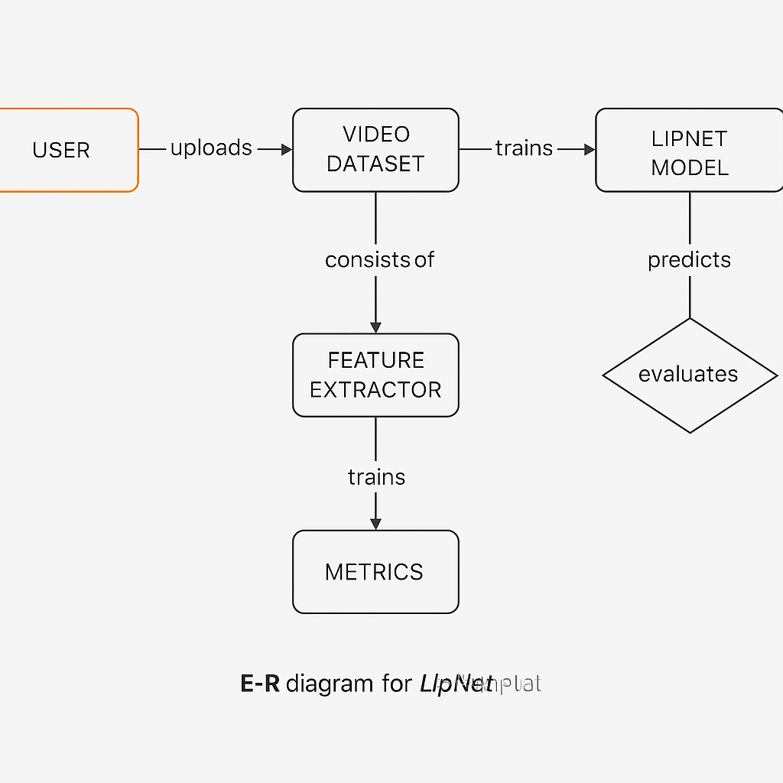
Fig. 3.1.2.1 ER Diagram

The diagram illustrates an Entity-Relationship Model of the Lip-Net system, beginning with the User, who provides a Video Input. The video is broken into multiple Frames, from which a Region of Interest (ROI) (lip movement) is extracted. These ROIs are passed to the Model, which has CNN and RNN Layers that together produce a Prediction. The predicted output is decoded using the CTC Decoder, and the final Sentence is stored or displayed.

3.1.3 DFD:-
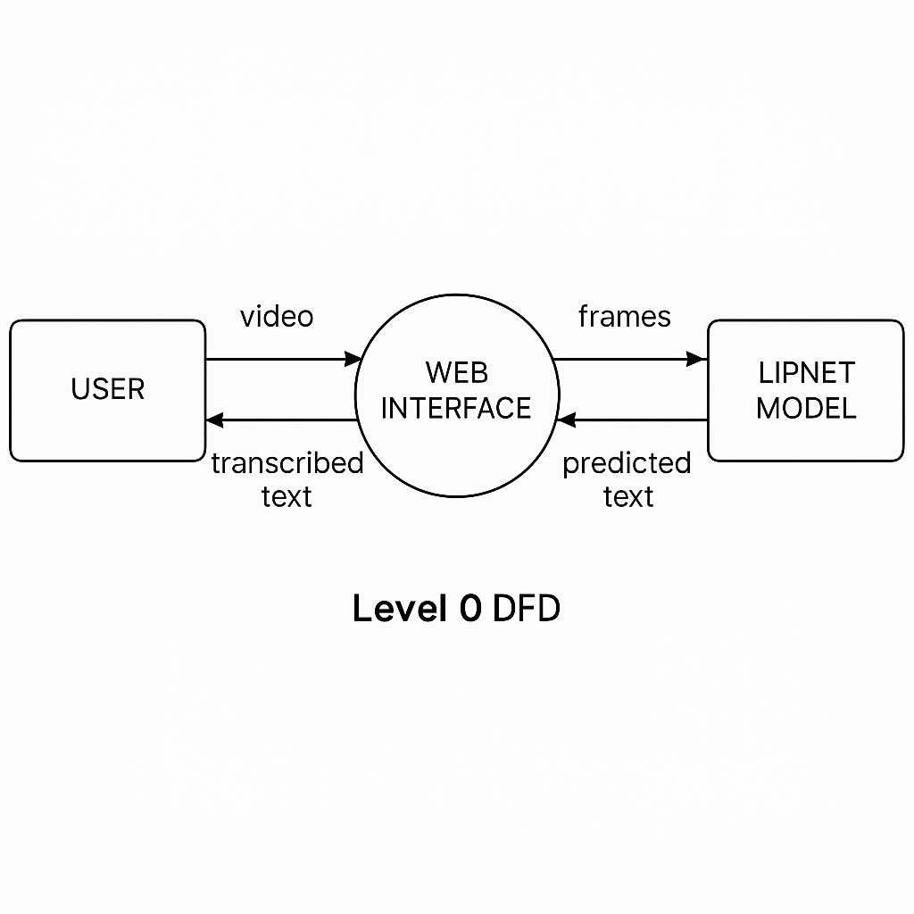
Level 0 DFD:-

Fig 3.1.3.1 Zero Level DFD

User Interaction:

The user provides a silent video as input via a GUI or script interface. The system receives the video and begins processing in real time.

Video Input Handler:

The video input module extracts individual frames, identifies and crops the lip region, and preprocesses each frame to standardize input for the deep learning mode.

Lip-Net Model:

The processed frames are fed into the Lip-Net model, where 3D CNNs analyze frame sequences and Bi-GRUs understand the temporal dependencies. The CTC Decoder processes the model’s output and converts it into a human-readable sentence.

LOW LEVEL DESIGN

The Low-Level Design (LLD) of Lip-Net details the internal system architecture, focusing on data flow, interactions, and implementation specifics. Lip-Net is a deep-learning-based lip-reading model, and its design ensures efficient video processing, accurate text prediction, and seamless user interaction.

User Interface Design

The user interface of Lip-Net is built for intuitive interaction, ensuring users can easily upload video sequences and retrieve accurate transcriptions. The interface includes essential elements such as a navigation bar for accessing features, an upload section for video input, and a progress indicator displaying the processing status. Once the model generates results, the transcribed text appears in an output panel, accompanied by a confidence score to indicate prediction reliability. Additionally, an error feedback mechanism is included to allow manual corrections, improving transcription accuracy.

Data Processing Pipeline:

Lip-Net follows a structured pipeline for processing video inputs before analysis. The system first extracts frames from the uploaded video, converting the sequence into discrete images for further evaluation. Facial detection algorithms identify the region of interest, focusing on the movement of lips rather than the entire face. These frames undergo preprocessing, including normalization to ensure consistency across different lighting conditions and camera angles. Feature extraction is then performed using convolutional neural networks (CNNs) to capture critical lip movement patterns, while recurrent neural networks (RNNs) analyze the sequence over time to generate contextual predictions.

Backend Architecture:

The backend is responsible for handling video processing, model execution, and delivering results efficiently. It includes a preprocessing module that converts video clips into suitable formats and extracts relevant features. The deep-learning engine integrates CNN and RNN components to predict spoken words based on lip movements. The system also includes an error correction module, which refines results before they are presented to the user. A RESTful API connects the model to the user interface, ensuring smooth interactions and real-time processing.

Model Deployment and Integration:

Lip-Net is deployed using optimized frameworks to ensure fast inference and accuracy. TensorFlow or PyTorch powers the core deep-learning model, while Flask or Django serves as the backend for managing API requests. WebSocket integration enables real-time interactions, allowing users to receive transcriptions instantly. Additionally, GPU and TPU acceleration enhance performance, making the system scalable for larger datasets and complex computations.

Data Flow and System Interaction:

The system follows a structured workflow to process lip-reading tasks efficiently. Users upload videos containing lip movements, which the model processes by extracting relevant features and analyzing movement sequences. Predictions are generated in the form of text, and the results are displayed in the interface alongside confidence scores. If needed, users can refine the output manually before finalizing the transcription. Processed results are then stored for future reference, ensuring a seamless experience.

CHAPTER 04
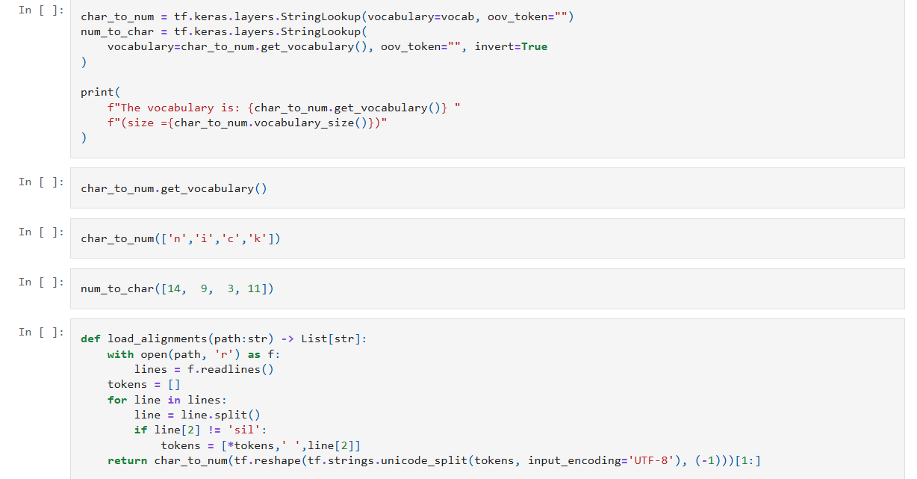
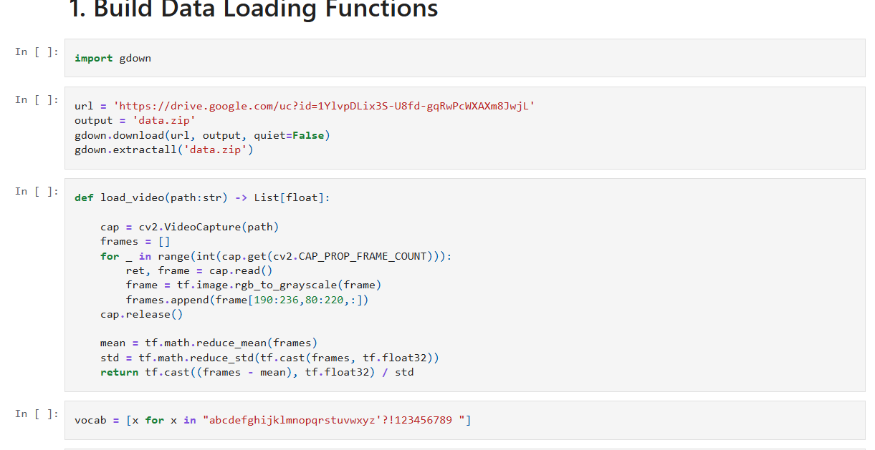
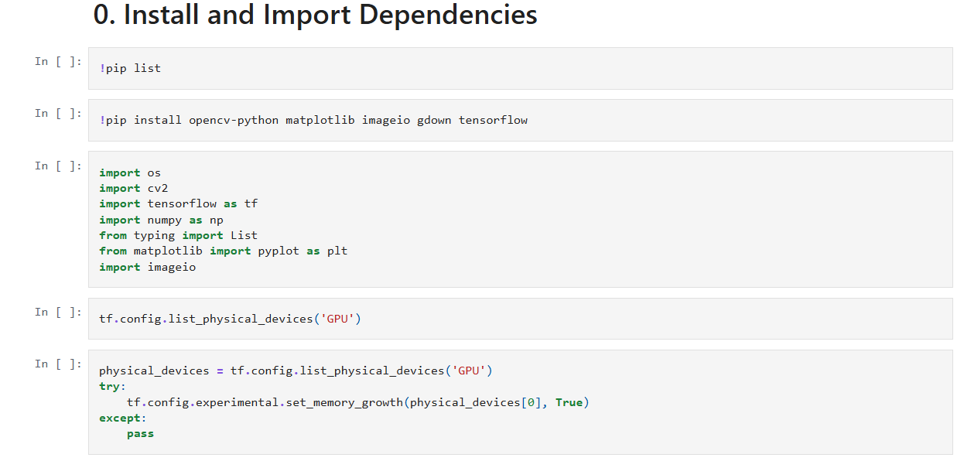
CODING
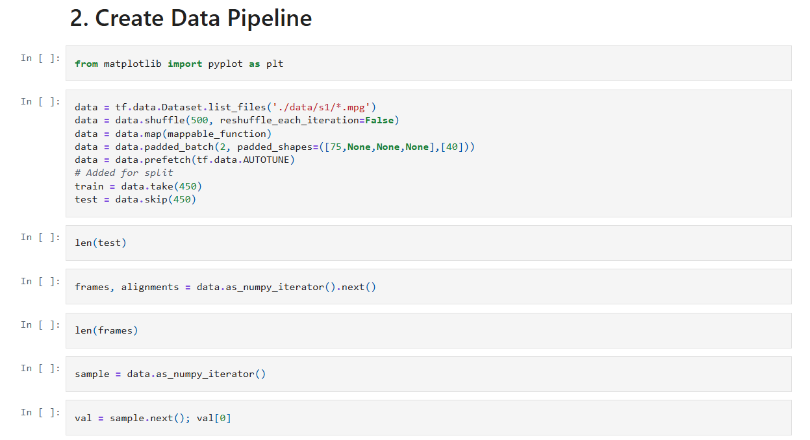
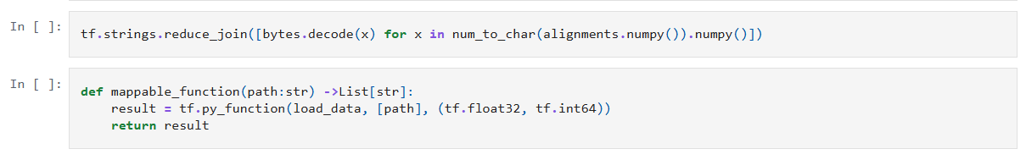
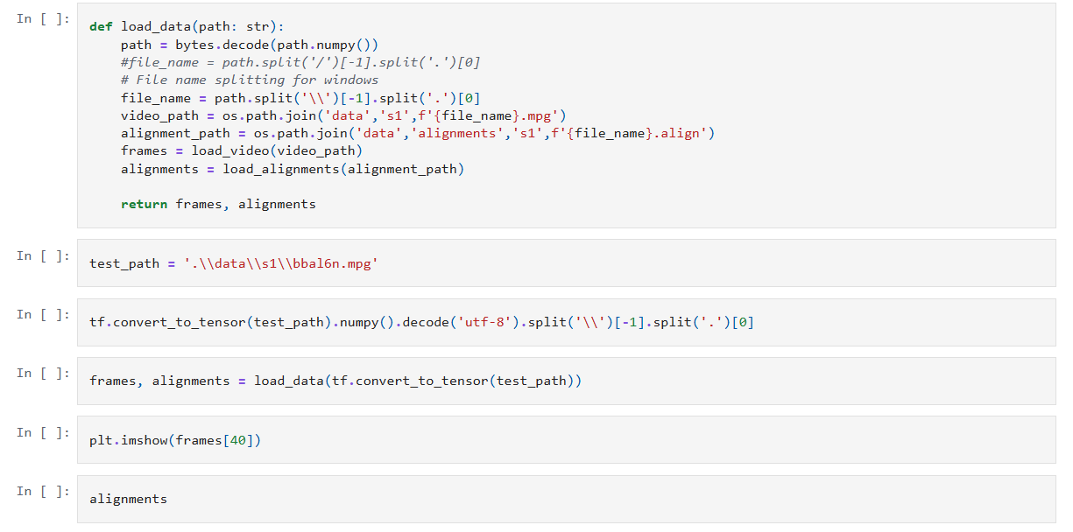

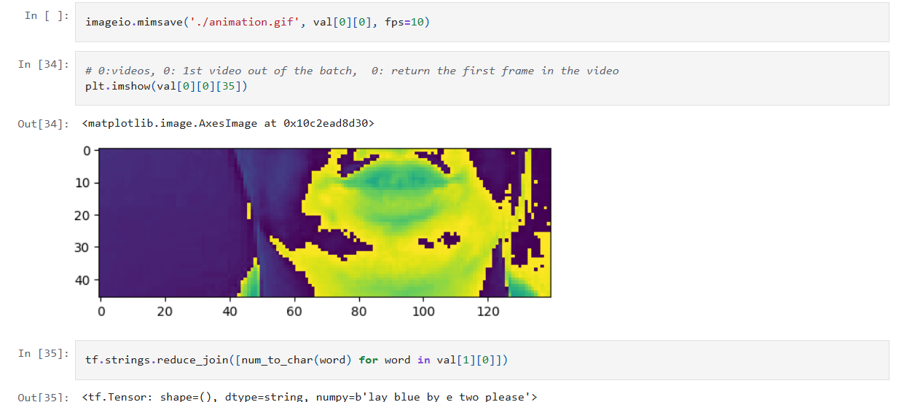
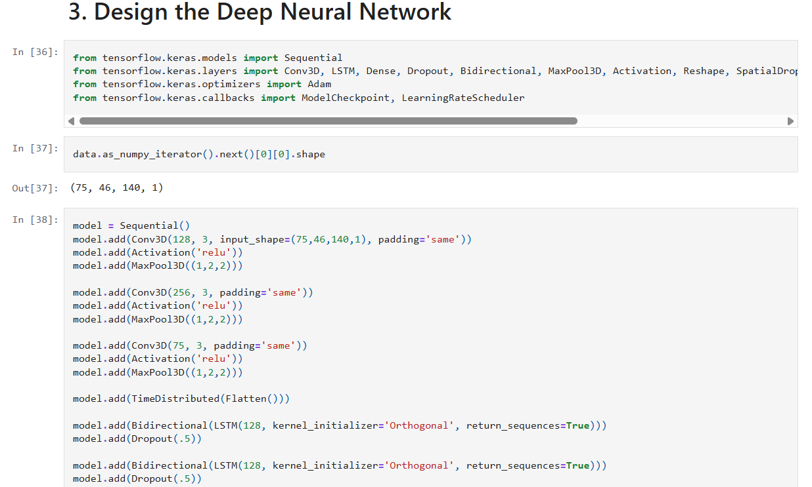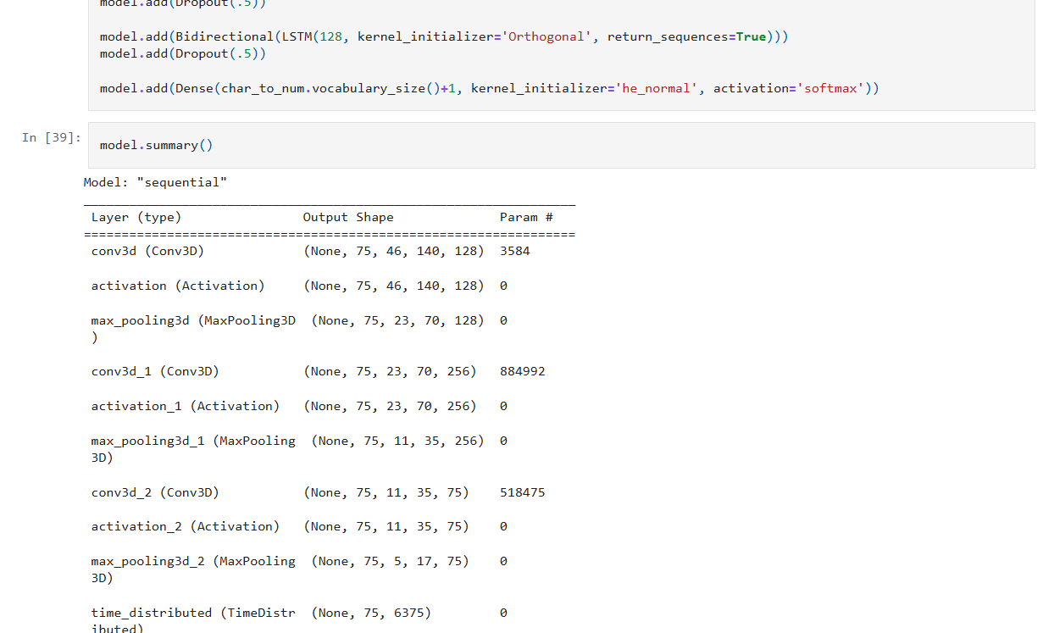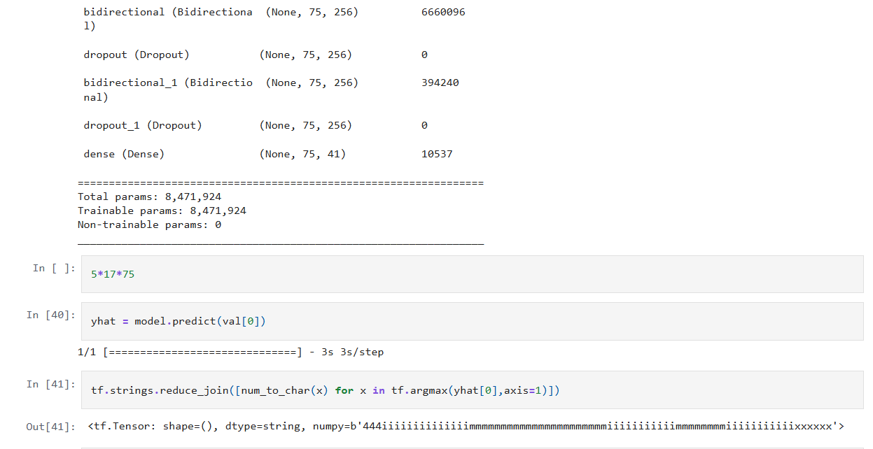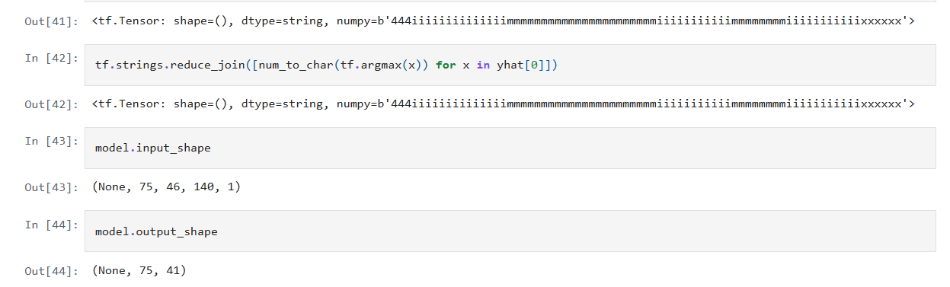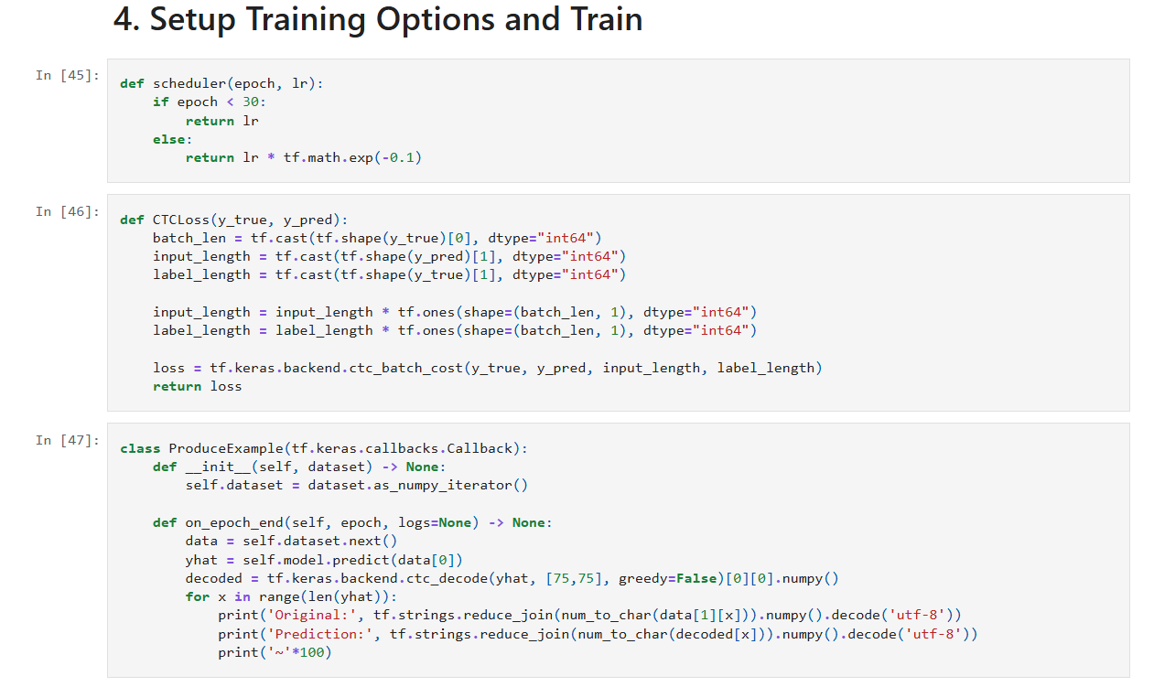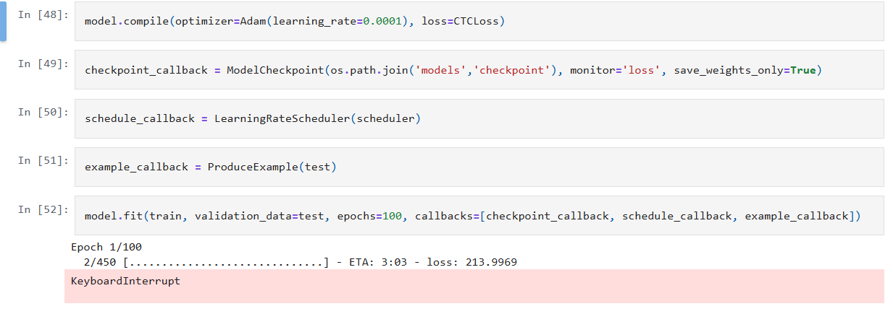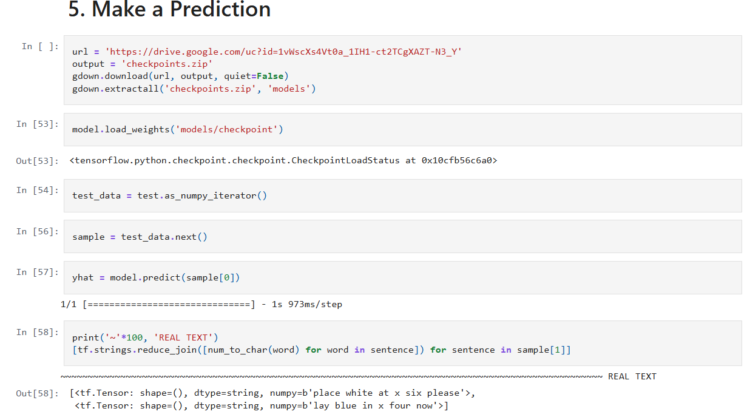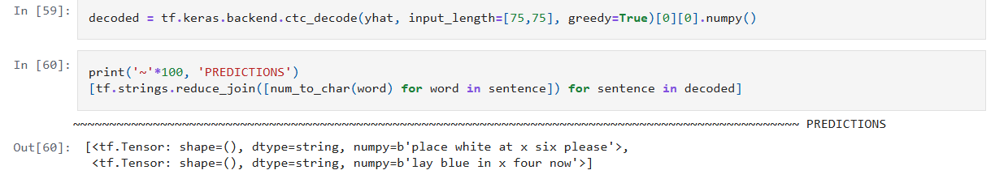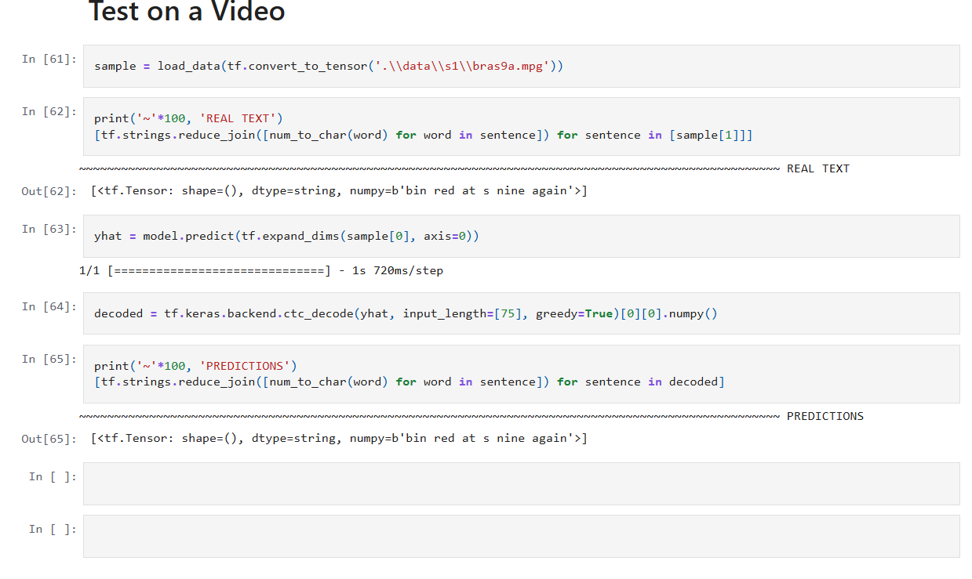

CHAPTER 05

TESTING

Unit Testing

Unit testing ensures that individual components of Lip-Net function correctly in isolation. The primary focus is on verifying the accuracy, efficiency, and robustness of the lip-reading algorithms, deep learning model, data preprocessing pipeline, and API interactions.

Main Components:-
    - Lip-Net Model Performance: Ensuring CNN and RNN components accurately process lip movements and generate correct transcriptions.
    - Input Validation & Preprocessing: Handling missing, noisy, or incorrect video formats. Edge cases include distorted frames, low resolution, and incomplete sequences.
    - Error Handling and Exception Management: Detecting model failures and ensuring error messages guide developers to quick resolutions.
    - Prediction Accuracy Tests:- Comparing generated transcriptions with ground truth data across various video samples.

Integration Testing

Integration testing verifies that all system modules interact seamlessly, ensuring data consistency, model efficiency, and smooth user experience

Main Components:-
    - Deep Learning Model & Backend Communication:
    - Testing real-time data exchange between the CNN-RNN model and backend logic. Correct handling of model outputs and transformation of results.
    - Evaluating model response time and accuracy under different video lengths.
    - Ensuring dynamic switching between training mode and inference mode.
    - User Input & Processing Pipeline:
    - Validating correct handling of uploaded videos and frame extraction.Handling multiple simultaneous summarization requests.
    - Ensuring preprocessing steps like lip region detection, alignment, and normalization function as expected.

CHAPTER 06

CONCLUSION & LIMITATIONS

6.1 Conclusion

In conclusion, the Lip-Net model demonstrates the potential of deep learning in
bridging the gap between visual speech recognition and textual interpretation. By leveraging spatiotemporal convolutional neural networks (3D CNNs),
bidirectional Long Short-Term Memory (Bi-LSTM), and the CTC loss function,
Lip-Net effectively decodes sequences of lip movements into coherent text
without the need for audio input. This system showcases the importance of end-
to-end training pipelines and efficient visual feature extraction in achieving high
accuracy in silent speech recognition tasks.

The project not only highlights the technical feasibility of lip reading through
neural networks but also opens new possibilities for silent communication,
assistive technologies for the hearing-impaired, and surveillance systems where
audio capture is not viable. With future enhancements such as real-time
processing, multilingual capability, and integration with speech-to-text
frameworks, Lip-Net sets a strong foundation for the next generation of visual
speech recognition systems.

6.2 Limitations

While the Lip-Net model represents a significant advancement in the field of visual speech recognition, it does face several limitations that may affect its adaptability in real-world applications. One of the primary constraints is its dependency on structured and limited datasets , which feature fixed vocabulary and grammar. This can hinder the model’s generalization to spontaneous, natural speech found in real-world scenarios.

Moreover, the system requires clear frontal facial video input under stable lighting conditions. Variations such as side profiles, poor lighting, facial obstructions (e.g., masks, beards), or low video resolution can reduce model accuracy. The visual similarity between certain speech sounds (visemes) also leads to potential misclassification, as different phonemes can appear nearly identical on the lips.

- The model is not optimized for real-time processing, limiting its current use to offline scenarios.
- Multilingual support is absent; the system has been trained solely on English-language datasets.
- The model’s performance may degrade when applied to unseen speakers, dialects, or fast-paced speech.
- High computational resources are required for both training and inference, making deployment challenging on low-power devices.

REFRENCES

[1] Lu, Y.; Li, H. “Automatic Lip-Reading System Based on Deep
Convolutional Neural Network and Attention-Based Long Short-
Term Memory,” Appl. Sci. 2019, 9, 1599.
https://doi.org/10.3390/app9081599

[2] Patricia Scanlon , Richard Reilly and Philip de Chazal, “Visual
Feature Analysis for Automatic Speech reading,” International
Conference on Audio-Visual Speech Processing, September 2003

[3] Priyanka P. Kapkar and S. D. Bharkad, “Lip Feature Extraction and
Movement Recognition Methods”, International Journal of Scientific
& Technology Research, vol.8, August 2019.

[4] Oscar Koller, Sepehr Zargaran and Hermann Ney, “Re-Sign: Re-
Aligned End-to-End Sequence Modeling with Deep Recurrent CNN-
HMM,” Human Language Technology & Pattern Recognition Group
RWTH Aachen University, Germany, 2017

[5] Tayyip Ozcan and Alper Basturk, "Lip Reading Using Convolutional
Neural Networks with and without Pre-Trained Models," Balkan
Journal of Electrical and Computer Engineering, Vol. 7, No. 2, April
2019.

[6] Amit Garg, Jonathan Noyola, Sameep Bagadia, “Lip reading using
CNN and LSTM,” 2016

[7] Abiel Gutierrez and Zoe-Alanah Robert, "Lip Reading Word
Classification", Stanford University, 2017

[8] Pooventhiran G, Sandeep A, Manthiravalli K, Harish D, Karthika and
Renuka D, “Speaker-Independent Speech Recognition using Visual
Features,” International Journal of Advanced Computer Science and
Applications, Vol. 11, No. 11, 2020

[9] Themos Stafylakis and Georgios Tzimiropoulos, “Combining
Residual Networks with LSTMs for Lip reading,” Computer Vision
Laboratory University of Nottingham, UK, arXiv:1703.04105v4
[cs.CV]
[10] http://www2.cmp.uea.ac.uk/~bjt/avletters/

[11] https://sites.google.com/site/achrafbenhamadou/-datasets/miracl-vc1

[12] https://www.robots.ox.ac.uk/~vgg/data/lip_reading/lrw1.html

[13] Vahid Kazemi and Josephine Sullivan, “One Millisecond Face
Alignment with an Ensemble of Regression Trees,” Proceedings of
the IEEE Conference on Computer Vision and Pattern Recognition.
2014.

[14] Mahmood, Ammar et al. “Automatic Hierarchical Classification of
Kelps Using Deep Residual Features.” Sensors (Basel, Switzerland)
vol. 20,2 447. 13 Jan. 2020, doi:10.3390/s20020447

[15] https://drive.google.com/u/1/uc?id=1ftS9GHYkOyQ-
hQdFvamTblYyIWQCTWud&export=download

